
Write a single ansible playbook which will install apache and nginx.
Note: Playbook should not be hardcoded and pass the variables from different file.
Create a variable file and paste the syntax:
packages:
- apache2
- nginx
services:
- apache2
- nginx
nginx_port: 8080
nginx_conf: /etc/nginx/sites-enabled/default

Syntax for Playbook:
- hosts: all
become: yes
vars_files:
- vars.yaml

tasks:
- package:
name: "{{ packages }}"
state: present

- service:
name: apache2
state: started
enabled: yes

- copy:
dest: "{{ nginx_conf }}"
content: |
server {
listen {{ nginx_port }};
location / {
root /var/www/html;
index index.html;
}
}

- service:
name: nginx
state: restarted
enabled: yes

after creating both files execute playbook command to install the packages
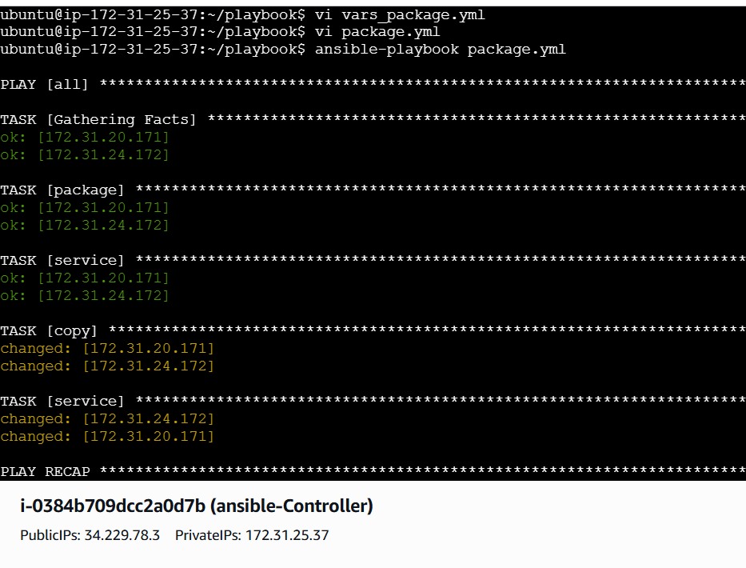
Successfully installed
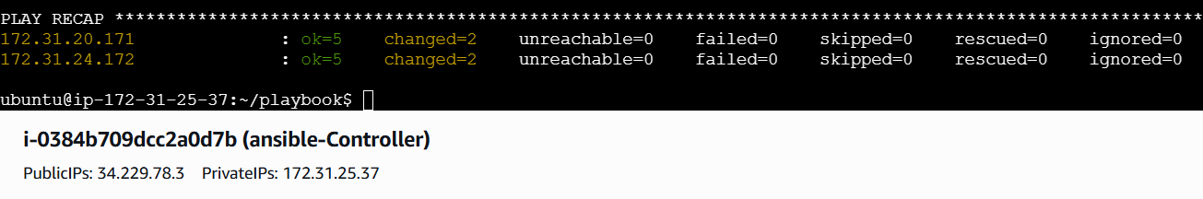
Validation of both servers and workers using publicip@port
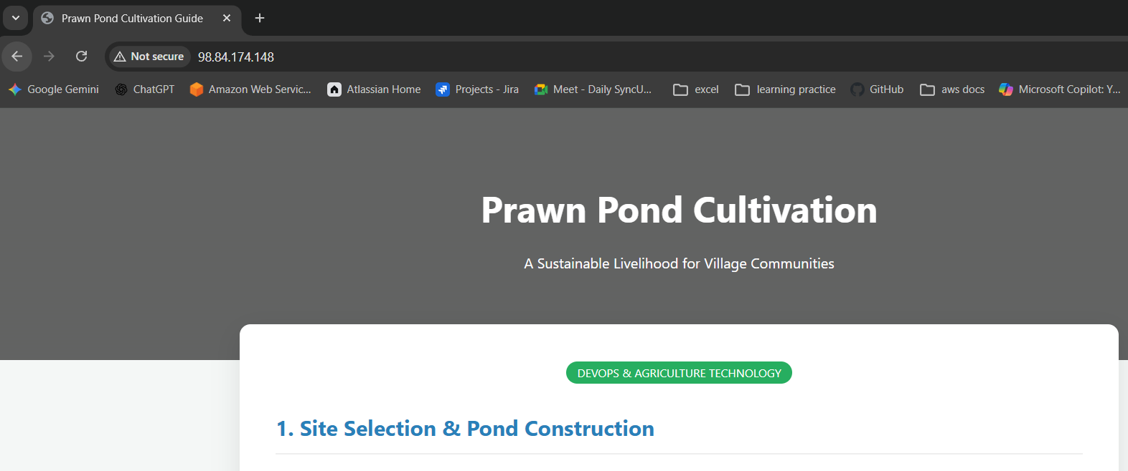
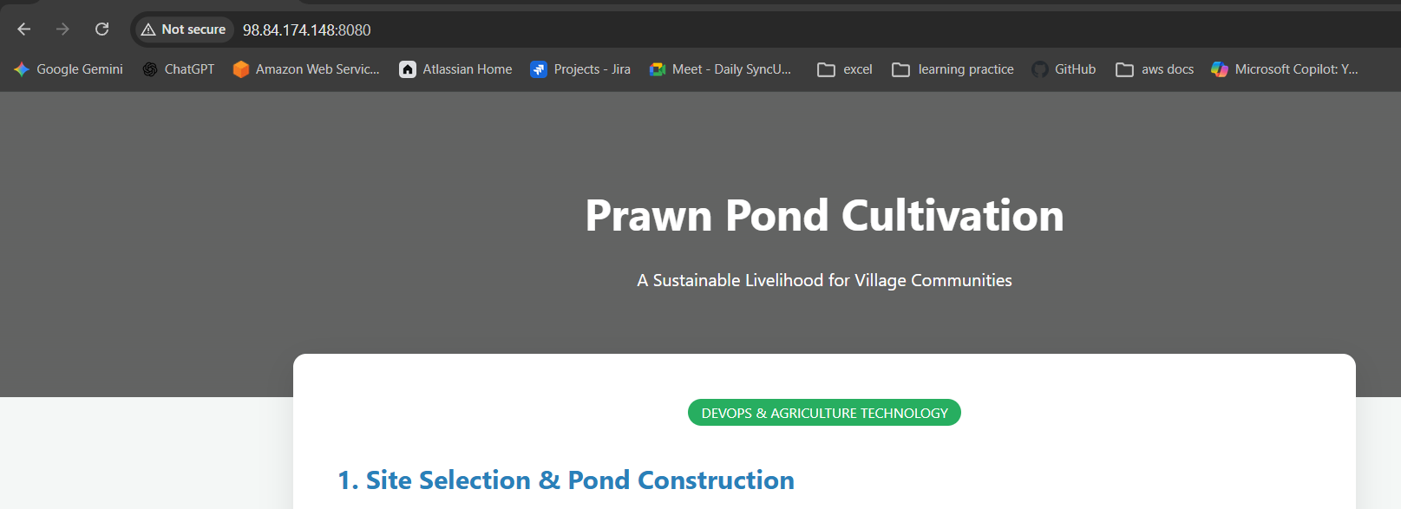
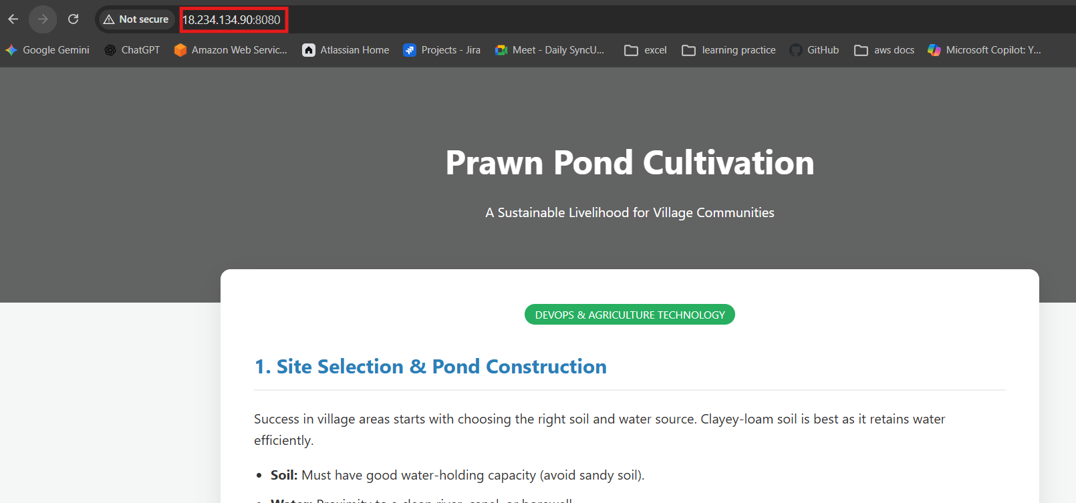
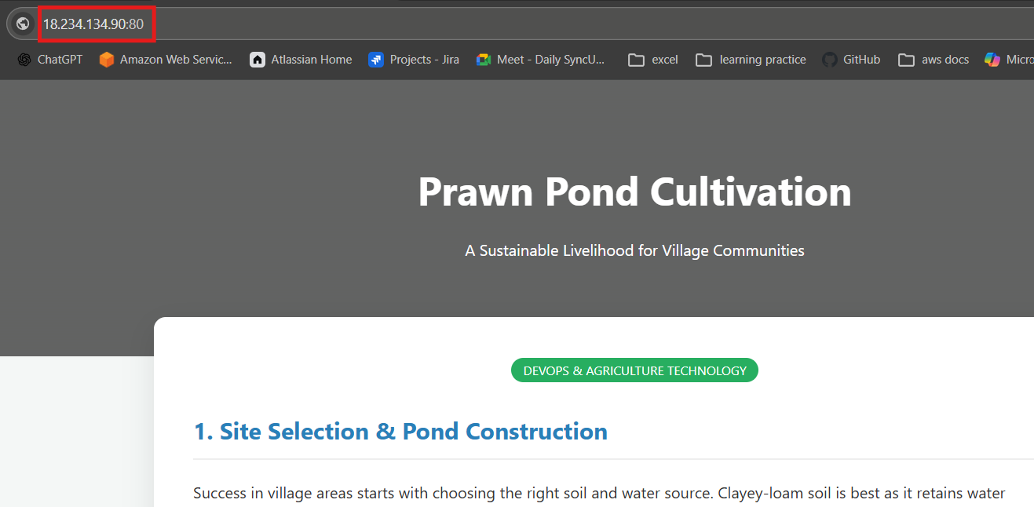

Ansible playbook to create 10 different directories with minimal code and directory names should be passed as variables.
Variable.yml syntax:
folder_names:
- analytics_01
- archive_base
- build_output
- db_dumps
- logs_internal
- staging_site
- test_results
- vendor_libs
- web_assets
- zone_configs

Playbook syntax:
---
- name: Create directories from external vars
hosts: localhost
vars_files:
- dir_vars.yml

tasks:
- name: Create directories iteratively
ansible.builtin.file:
path: "./{{ item }}"
state: directory
mode: '0755'
loop: "{{ folder_names }}"

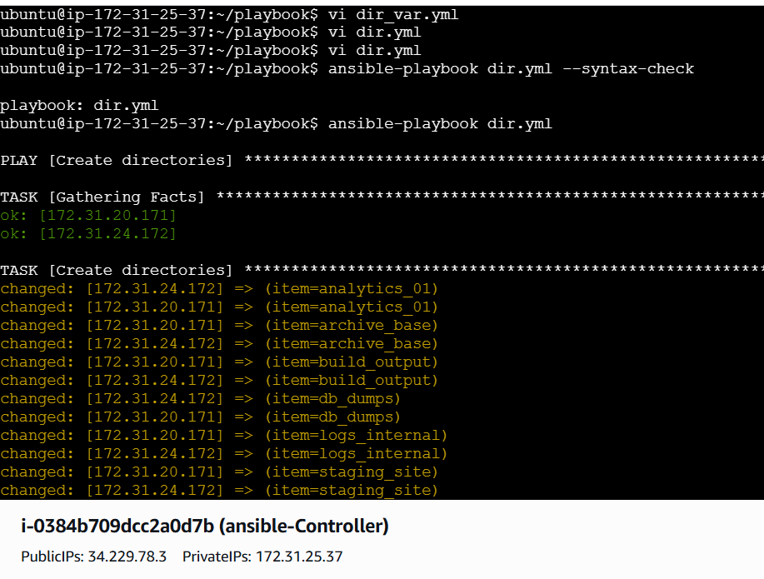
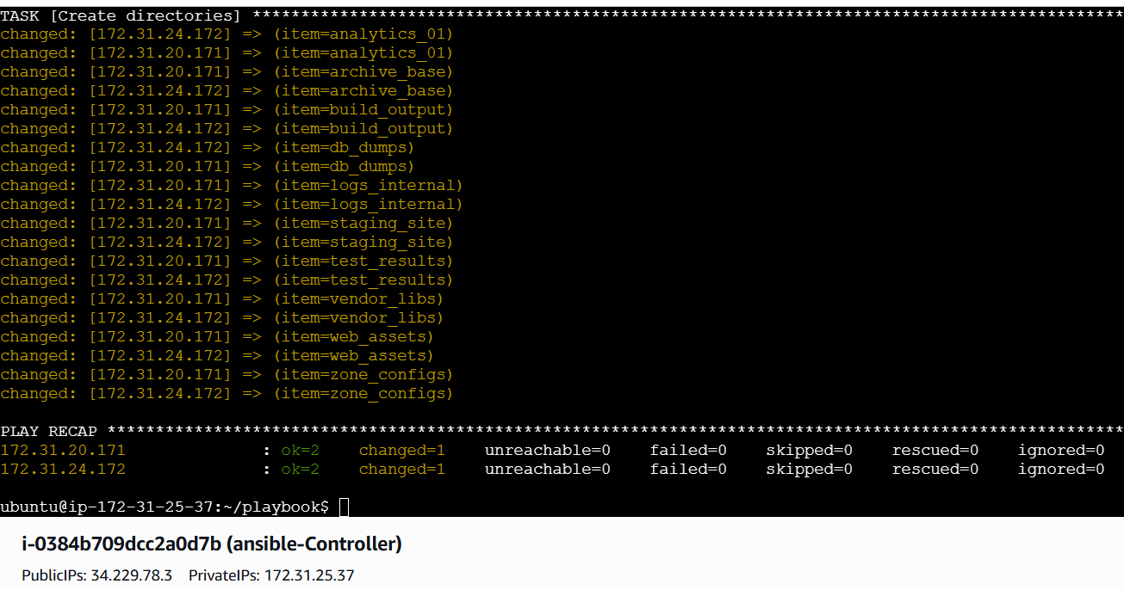

The directories are created in root location
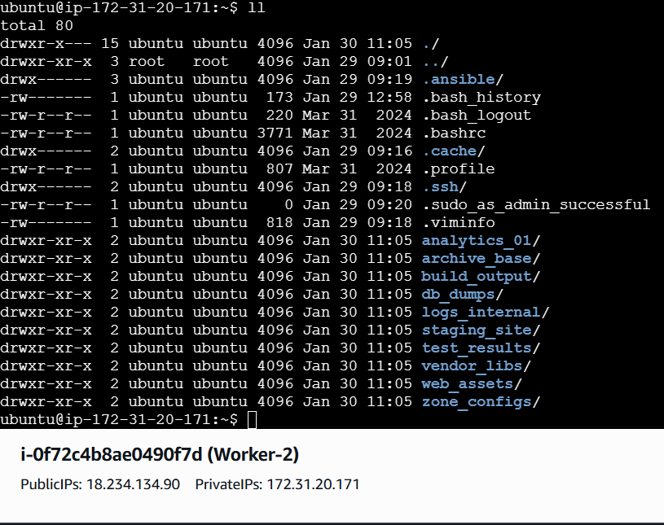
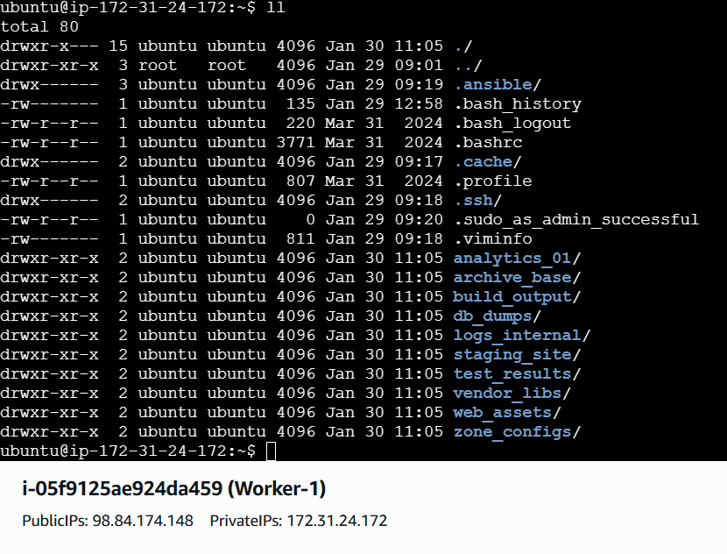
Ansible playbook to copy ssh-keygen from master to worker nodes.
Note:
a)Provision new 3 ec2 machines, one master and two worker nodes.
b)Create common user called ansadm and provide sudo priviliges on 3 ec2 instances.
c)Create ssh-keygen in master and your playbook should copy the keygen making it password less authentication.

Prerequisites:
1. Infrastructure & Access
- Active Ansible Controller: You must have a control node (EC2 instance) with Ansible installed and a public IP to manage the target nodes.
- Security Group Rules: The Security Group attached to your 3 new instances must allow Inbound SSH (Port 22) from your Controller's Private or Public IP.
- Original AWS Key Pair: You must have the private key file (sshless.pem) stored on your Controller with permissions set to chmod 400.
2. Controller Configuration
- Ansible Inventory: Your /etc/ansible/hosts file must be correctly partitioned into [master] and [workers] groups.
- SSH Key on Controller: You must have already generated a local key on the Controller using ssh-keygen if you intend to manage the cluster as ansadm later.
- Python Dependencies: Ensure python3 and the python3-pip packages are installed on the Controller and all target nodes for Ansible modules to function.

3. Software Requirements
- ACL Package: The acl package must be available for installation on the target Ubuntu nodes to handle privilege escalation (become_user: ansadm).
- Ansible Collections: Ensure the amazon.aws collection is installed if you are performing the provisioning step from the Controller.
- Correct AMI: Ensure you are using an Ubuntu-based AMI for the 3 instances, as the playbooks are configured for the ubuntu default user and the sudo group.

Step 1: Provision 3 EC2 Instances
Run this playbook from your Controller to launch your 1 Master and 2 Worker nodes. You will need your AWS credentials configured on the Controller.
Syntax:
---
- name: Provision Infrastructure
hosts: localhost
tasks:
- name: Launch 3 EC2 Instances
amazon.aws.ec2_instance:
name: "{{ item.name }}"
key_name: "sshless" # The key pair name in your AWS Console
instance_type: t2.micro
image_id: ami-0c55b159cbfafe1f0 # Ensure this is an Ubuntu AMI
region: us-east-1
tags:
Role: "{{ item.role }}"
loop:
- { name: 'Ansible-Master', role: 'master' }
- { name: 'Worker-01', role: 'worker' }
- { name: 'Worker-02', role: 'worker' }

Step 2: Update Your Inventory
Once the instances are running, get their Public IPs and add them to your inventory file.
File: /etc/ansible/hosts
[master]
13.xxx.xxx.10 # Master Public IP
[workers]
13.xxx.xxx.11 # Worker 01 Public IP
13.xxx.xxx.12 # Worker 02 Public IP
Step 3: Create User & Sudo Privileges
This playbook targets all nodes to ensure the ansadm user exists and can run commands as root without a password.
---
- name: Phase A & B - Setup User and Sudo
hosts: all
become: yes
tasks:
- name: Install ACL for privilege escalation
ansible.builtin.apt:
name: acl
state: present

- name: Create ansadm user
ansible.builtin.user:
name: ansadm
shell: /bin/bash
groups: sudo
append: yes

- name: Grant passwordless sudo to ansadm
ansible.builtin.lineinfile:
path: /etc/sudoers.d/ansadm
line: "ansadm ALL=(ALL) NOPASSWD:ALL"
create: yes
mode: '0440'
validate: '/usr/sbin/visudo -cf %s'
Execution Command:
ansible-playbook -i /etc/ansible/hosts 01_create_user.yml -u ubuntu --private-key=sshless.pem

Step 4: Master-to-Worker SSH Exchange
Once the user is created, run this playbook to handle Task (C). This generates the key on the New Master and pushes it to the Workers.
Syntax:
---
- name: Generate Key on Master
hosts: master
tasks:
- name: Ensure .ssh directory exists for ansadm
become: yes
ansible.builtin.file:
path: /home/ansadm/.ssh
state: directory
owner: ansadm
group: ansadm
mode: '0700'

- name: Generate SSH Key for ansadm on Master
become: yes
become_user: ansadm
ansible.builtin.openssh_keypair:
path: /home/ansadm/.ssh/id_rsa
type: rsa
size: 4096

- name: Read Master public key for distribution
become: yes
ansible.builtin.slurp:
src: /home/ansadm/.ssh/id_rsa.pub
register: master_pub_key

- name: Distribute Key to Workers
hosts: workers
tasks:
- name: Add Master public key to Worker authorized_keys
become: yes
become_user: ansadm
ansible.posix.authorized_key:
user: ansadm
state: present
key: "{{ hostvars[groups['master'][0]]['master_pub_key']['content'] | b64decode }}"
Execution Command:
Bash
ansible-playbook -i /etc/ansible/hosts 02_ssh_exchange.yml -u ubuntu --private-key=sshless.pem

Step 5: Final Execution Command
Run the following commands from your Controller terminal. Use the sshless.pem file you created on your server to establish the initial connection.
# 1. Ensure key security
chmod 400 sshless.pem

# 2. Bypass fingerprint prompts
export ANSIBLE_HOST_KEY_CHECKING=False

# 3. Run the configuration
ansible-playbook -i /etc/ansible/hosts full_setup.yml -u ubuntu --private-key=sshless.pem

Step 5: Verification
To confirm everything is correct, log into your New Master and try to jump to a Worker:
- ssh -i sshless.pem ubuntu@<MASTER_IP>
- sudo su - ansadm
- ssh <WORKER_PRIVATE_IP>

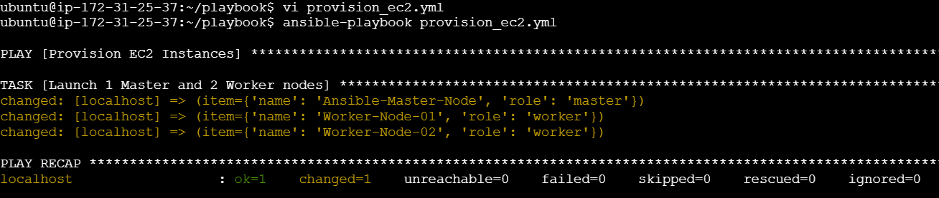
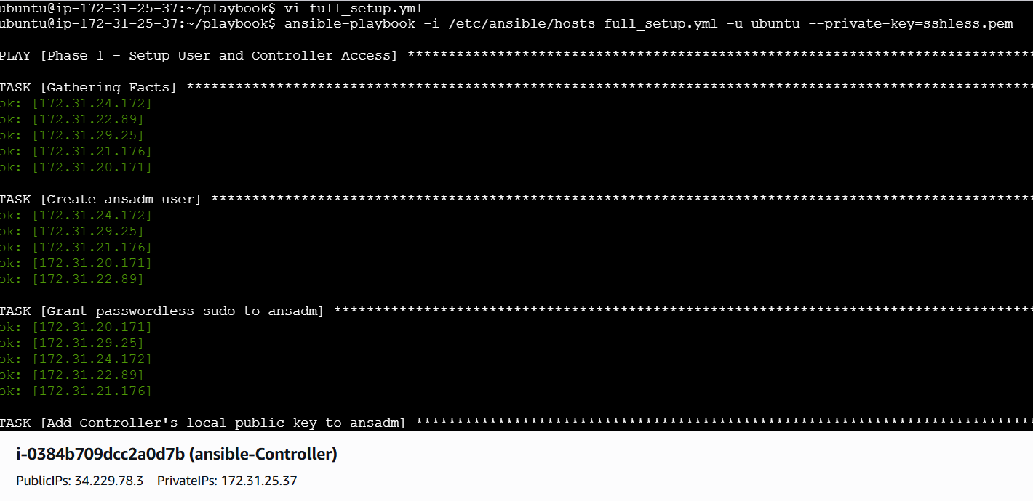
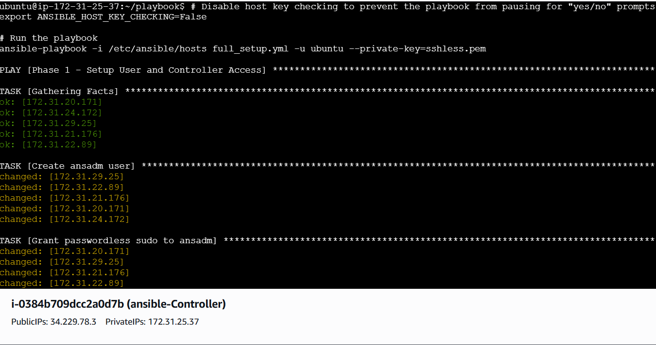
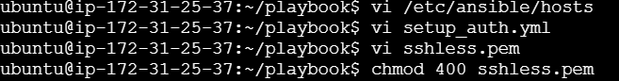

Validation:
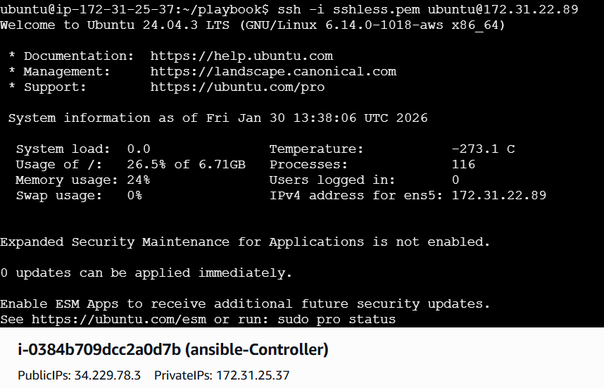
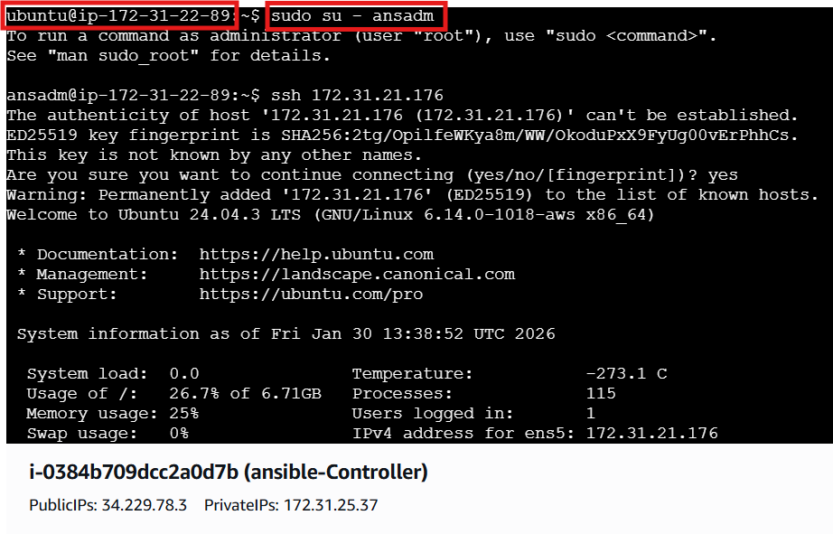
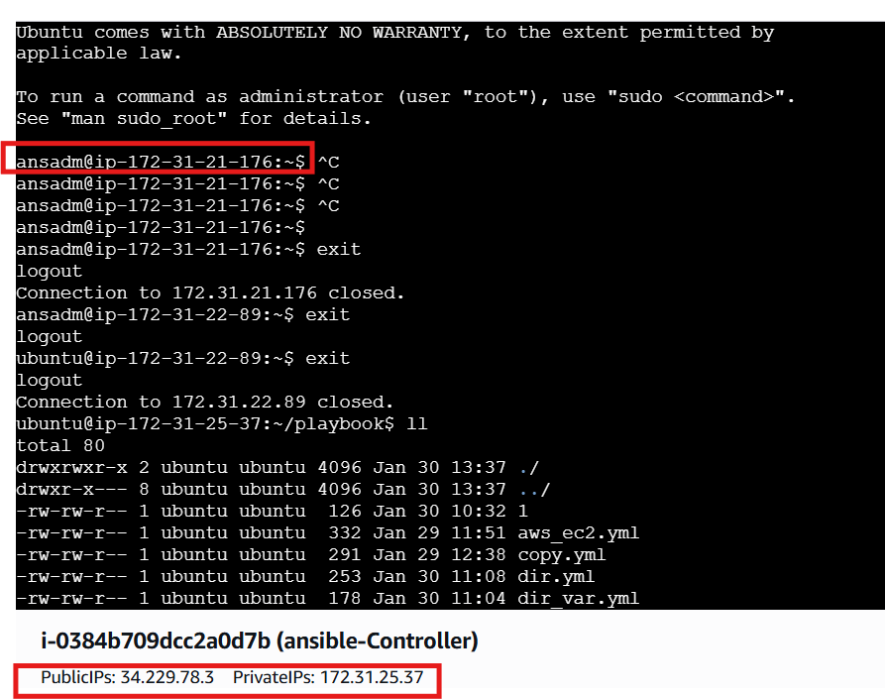
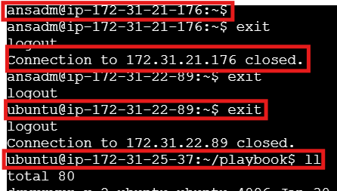
Commands and their usage:
• chmod 400 sshless.pem: This command changes the file permissions of your private key to "read-only" for the owner. SSH will reject a key if it is "too open" (readable by others), as this is a security risk.

• export ANSIBLE_HOST_KEY_CHECKING=False: This environment variable tells Ansible to skip the "Are you sure you want to continue connecting (yes/no)?" prompt for new servers. This is essential for automation so the playbook doesn't hang waiting for manual input.

User Creation (01_create_user.yml)
This phase establishes the identity you will use to manage the servers.
- ansible.builtin.apt (name=acl): Installs the Access Control List package. Without this, Ansible cannot safely use become_user to switch from root to ansadm.
- ansible.builtin.user: Creates the ansadm user account and assigns it to the sudo group, which is the standard admin group for Ubuntu.
- ansible.builtin.lineinfile: Edits the /etc/sudoers.d/ansadm file to add NOPASSWD:ALL. This allows the ansadm user to run root commands without being prompted for a password, which is required for non-interactive automation.
- visudo -cf %s: This is a validation check. It ensures the sudoers file you just created has no syntax errors before saving it.
SSH Key Exchange (02_ssh_exchange.yml)
This phase builds the "trust" between your Master and Worker nodes.
- ansible.builtin.openssh_keypair: Runs only on the Master node to generate a 4096-bit RSA key pair (public and private) specifically for the ansadm user.
- ansible.builtin.slurp: This is a powerful module that reads the content of a file (the Master's public key) and encodes it in base64 so the Controller can store it in a variable called master_pub_key.
- ansible.posix.authorized_key: Runs on the Worker nodes. It takes the public key stored by the Controller and injects it into the /home/ansadm/.ssh/authorized_keys file.

4.Execution Command Breakdown
When you run the playbook, the flags tell Ansible how to "talk" to the new servers:
Bash
ansible-playbook -i /etc/ansible/hosts 02_ssh_exchange.yml -u ubuntu --private-key=sshless.pem
- -i /etc/ansible/hosts: Points to your inventory file where the Master and Worker IPs are listed.
- -u ubuntu: Tells Ansible to log in as the default AWS user (ubuntu) because the ansadm user’s SSH access isn't fully ready yet.
- --private-key=sshless.pem: Uses your original AWS private key for the initial connection.

5. Verification Commands
After the playbooks finish, use these commands to ensure everything is perfect:
- ansible all -m shell -a "sudo whoami" -u ansadm: Confirms that the ansadm user can successfully escalate to root on all nodes without a password.
- ssh -v ansadm@<WORKER_IP>: Running ssh with the -v (verbose) flag is helpful for troubleshooting if a connection is refused; it shows you exactly where the authentication is failing.

Ansible playbook to inject ansible vault variables.
Created a secrets file and provided password and verified in CLI
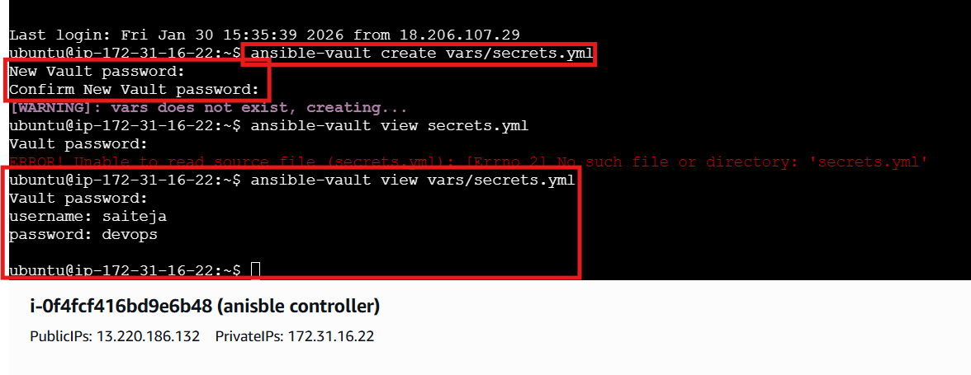
Unable to view the content manually
Because its encrypted
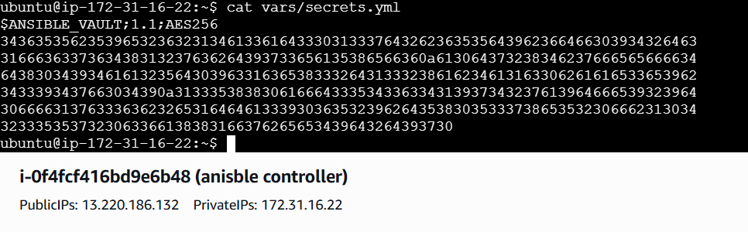
Using decryption to see the content
